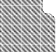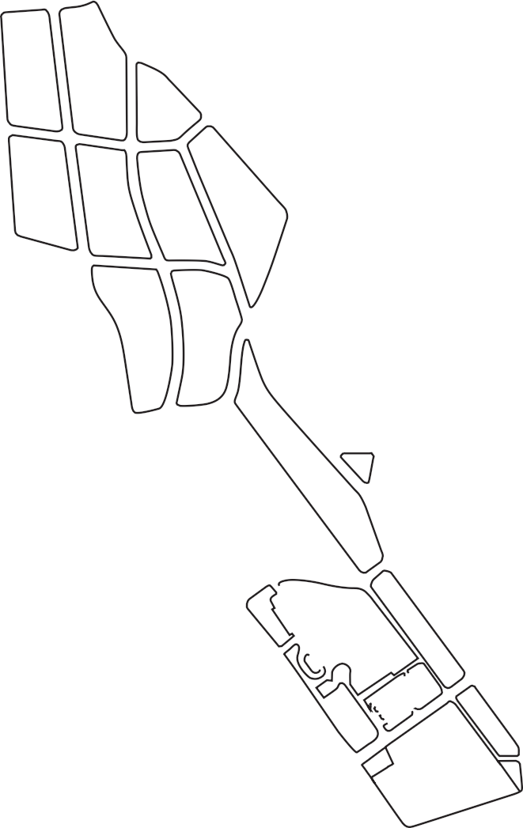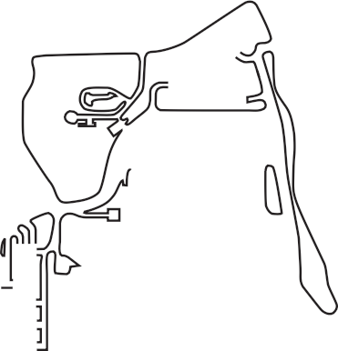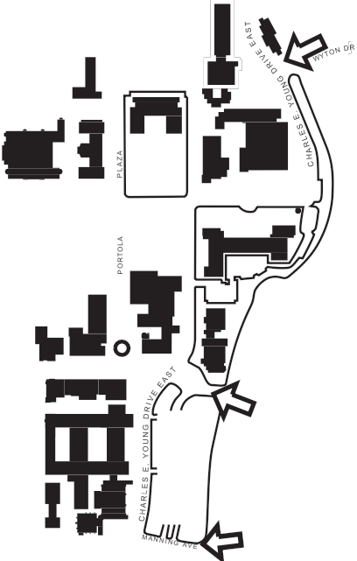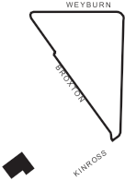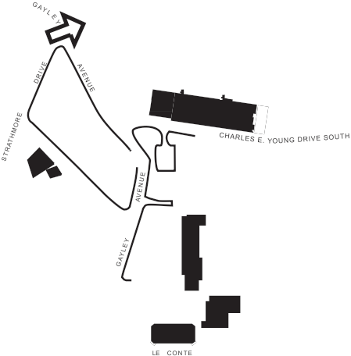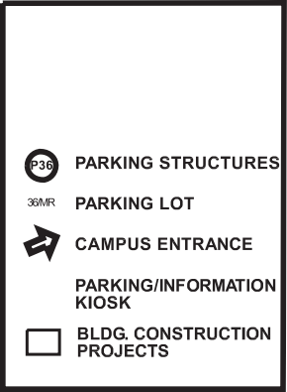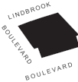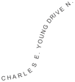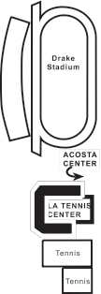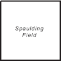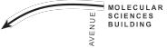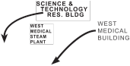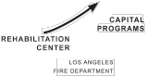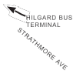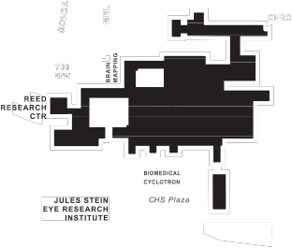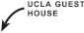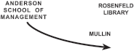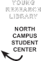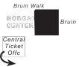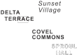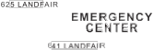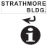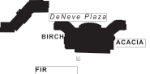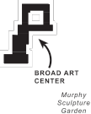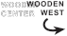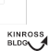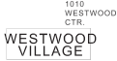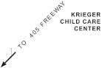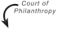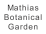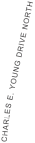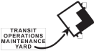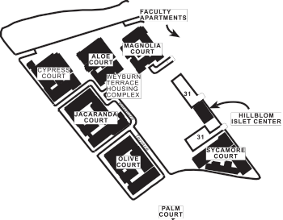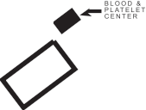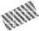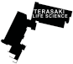
July 2013

SPROUL COVE

COURT OF SCIENCES STUDENT
CENTER

You can pay to park in the parking structure here. No validations.
Go to the 2nd floor, and CHS 23-105 should be the corner room.

Street/metered parking is available on Weyburn or Tiverton or Le Conte. See green dotted areas. ------
After parking, walk north on Tiverton Drive towards Dentistry. The entrance to the building is on your left.

WEYBURN GRADUATE STUDENT HOUSING

July 2013

CAMPUS BUILDING............................................... Grid ....... Street Address*
July 2013
Ackerman Student Union.................................................... E4 ............ 308 Westwood Plaza
Acosta Training Center ........................................................ D4 ........... 410 Charles E. Young Dr. West
Anderson School of Management ................................... E3
Collins Executive Education Center ............................ E3 ............ 110 Westwood Plaza
Cornell Hall........................................................................... E3 ............ 110 Westwood Plaza
Entrepreneurs Hall ............................................................ E3 ............ 110 Westwood Plaza
Korn Convocation Hall ..................................................... E3 ............ 110 Westwood Plaza
Gold Hall ............................................................................... E3 ............ 110 Westwood Plaza
Mullin Management Commons ................................... E3 ............ 110 Westwood Plaza
Rosenfeld Library............................................................... E3 ............ 110 Westwood Plaza
Ashe Center .............................................................................. E4 ............ 221 Westwood Plaza
Bank of America Bldg. .......................................................... E7 ............ 924 Westwood Blvd.
Biomedical Cyclotron ............................................................ E6 ............ 780 Westwood Plaza
Biomedical Sciences Research Bldg (BSRB)................... F5 ............ 615 Charles E. Young Dr. South
Boelter Hall (Engineering II & III) ....................................... E5 ............ 580 Portola Plaza
Botany Bldg. ............................................................................. F5 ............ 618 Charles E. Young Dr. South
Boyer Hall .................................................................................. F5 ............ 611 Charles E. Young Dr. East
Bradley International Hall.................................................... C4............ 417 Charles E. Young Dr. West
Brain Mapping ......................................................................... E5 ............ 660 Charles E. Young Dr. South
Brain Research Institute (BRI) ............................................. E6 ............ 670 Charles E. Young Dr. South
Broad Art Center ..................................................................... F2 ............ 240 Charles E. Young Dr. North
Broxton Plaza ........................................................................... D7 ........... 911 S. Broxton
Bunche Hall............................................................................... F3 ............ 315 Portola Plaza
Campbell Hall .......................................................................... F3 ............ 335 Portola Plaza
Campus Services Bldg. I ...................................................... D5 ........... 741 Charles E. Young Dr. South
Canyon Point (Sunset Village) ............................................ C3............ 200 DeNeve Dr.
Capital Programs Bldg. ........................................................ D8 ........... 1060 Veteran Ave.
Center for Health Sciences .................................................. E6 ............ 10833 LeConte Ave.
(includes David Geffen School of Medicine)
Central Ticket Office .............................................................. D4 ........... 325 Westwood Plaza
Clinical Research ..................................................................... F6 ............ 700 Tiverton Ave.
CNSI Building ........................................................................... E5 ............ 570 Westwood Plaza
Court of Sciences Student Center .................................... E5 ............ 617 Charles E. Young Dr. East
Courtside (Sunset Village) ................................................... C3............ 200 DeNeve Dr.
Covel Commons (Sunset Village) ...................................... C3............ 200 DeNeve Dr.
CRA Modular Units................................................................. B2............ 101 DeNeve Dr.
Delta Terrace (Sunset Village)............................................. C3............ 200 DeNeve Dr.
Dentistry, School of ............................................................... F5 ............ 714 Tiverton Ave.
DeNeve Housing Complex.................................................. C4
A - Acacia Residential Bldg. ............................................ C4............ 341 Charles E. Young Dr. West
B - Birch Residential Bldg. ............................................... C4............ 361 Charles E. Young Dr. West
C - Cedar Residential Bldg. ............................................. C4............ 301 Charles E. Young Dr. West
D - Dogwood Residential Bldg...................................... C4............ 321 Charles E. Young Dr. West
E - Evergreen Residential Bldg. ..................................... C4............ 331 Charles E. Young Dr. West
F - Firgrove Residential Bldg. ......................................... C4............ 381 Charles E. Young Dr. West
G - Gardenia Residential Bldg........................................ B4............ 470 Gayley Ave.
H - Holly Residential Bldg. .............................................. B4............ 345 DeNeve Dr.
DeNeve Commons Bldg. ................................................. C4............ 351 Charles E. Young Dr. West
Dodd Hall .................................................................................. F3 ............ 390 Portola Plaza
Doris Stein Eye Research Center ....................................... E6 ............ 200 Stein Plaza
Drake Track & Field Stadium ............................................... C4............ 340 Charles E. Young Dr. North
Dykstra Hall............................................................................... C4............ 401 Charles E. Young Dr. West
East Melnitz .............................................................................. F2 ............ 235 Charles E. Young Dr. East
Easton Women’s Softball Field ........................................... B2............ 100 DeNeve Dr.
EH&S Services Bldg. ............................................................... D5 ........... 550 Charles E. Young Dr. West
Engineering IV ......................................................................... E5 ............ 420 Westwood Plaza
Engineering V........................................................................... E5 ............ 410 Westwood Plaza
Extension Lindbrook Center............................................... D8 ........... 10934-10936 Lindbrook Dr.
Facilities Management Bldg. .............................................. D5 ........... 731 Charles E. Young Dr. South
Factor Health Sciences Bldg. .............................................. F5 ............ 700 Tiverton Ave.
Faculty Center.......................................................................... F4 ............ 480 Charles E. Young Dr. East
Faculty Apartments-Gayley ................................................ C6............ 715 Gayley
Faculty Apartments-Levering ............................................ C7............ 827 Levering
Fernald Center ......................................................................... E2 ............ 320 Charles E. Young Dr. North
Fielding School of Public Health ....................................... E5 ............ 640 Charles E. Young Dr. South
Fleet Services/Garage ........................................................... D5 ........... 751 Charles E. Young Dr. South
Fowler Museum (Cultural History) ................................... E3 ............ 308 Charles E. Young Dr. North
Franz Hall ................................................................................... F4 ............ 502 Portola Plaza
Gayley Towers .......................................................................... C5............ 565 Gayley Ave.
Geffen Playhouse.................................................................... E7 ............ 10886 LeConte Ave.
Geology Bldg. ......................................................................... F5 ............ 595 Charles E. Young Dr. East
Gonda (Goldschmeid) Center ............................................ E5 ............ 695 Charles E. Young Dr. South
Graduate School of Education
& Information Studies (GSE&IS).................................. E3 ............ 290 Charles E. Young Dr. North
Haines Hall ................................................................................ F3 ............ 375 Portola Plaza
Hammer Museum .................................................................. E8 ............ 10889 Wilshire Blvd.
Hedrick Hall .............................................................................. B3............ 250 DeNeve Dr.
Hedrick Summit ...................................................................... B3............ 240 DeNeve Dr.
Hershey Hall ............................................................................. F5 ............ 801 Hilgard Ave.
Hillblom Islet Research Center........................................... C7............ 900 Weyburn Place North
Hilgard Bus Terminal ............................................................. G4 ........... 403 Hilgard Ave.
Hitch Residential Suites........................................................ B3............ 245 DeNeve Dr.
Humanities Bldg. .................................................................... F4 ............ 415 Portola Plaza
Jules Stein Eye Institute........................................................ E6 ............ 100 Stein Plaza
Kaufman Hall............................................................................ E3 ............ 120 Westwood Plaza
Kerckhoff Hall........................................................................... E4 ............ 308 Westwood Plaza
Kinross Bldg. ............................................................................. D8 ........... 11000 Kinross Ave.
Kinross Bldg. South ................................................................ D8 ........... 11020 Kinross Ave.
Knudsen Hall ............................................................................ F4 ............ 475 Portola Plaza
Krieger Child Care Center .................................................... A2............ 101 Bellagio Dr.
LaKretz Hall ............................................................................... E5 ............ 619 Charles E. Young Dr. East
Lath House ................................................................................ F6 ............ 707 Tiverton Ave.
Law, School of.......................................................................... G3 ........... 385 Charles E. Young Dr. East
Landfair Apartments ............................................................. C5............ 625-641 Landfair Ave.
Life Sciences Bldg. .................................................................. E5 ............ 621 Charles E. Young Dr. South
Los Angeles Tennis Center (Straus Stadium) ................ D4 ........... 420 Charles E. Young Dr. West
Luskin School of Public Affairs........................................... F3 ............ 337 Charles E. Young Dr. East
Lu Valle Commons.................................................................. F3 ............ 398 Portola Plaza
MacDonald Medical Research Labs (MRL)..................... E5 ............ 675 Charles E. Young Dr. South
Macgowan Hall........................................................................ F2 ............ 245 Charles E. Young Dr. East
Macgowan East ....................................................................... F2 ............ 243 Charles E. Young Dr. East
Margan Apartments .............................................................. C7............ 885 Levering Ave.
Marion Davies Children’s Center ....................................... E6 ............ 805 Tiverton Ave.
Mathematical Sciences Bldg............................................... E4 ............ 520 Portola Plaza
Mattel Children’s Hospital ................................................... D6
Melnitz Hall ............................................................................... F2 ............ 235 Charles E. Young Dr. East
Molecular Sciences Bldg. .................................................... F5 ............ 609 Charles E. Young Dr. East
Moore Hall................................................................................. E4 ............ 457 Portola Plaza
Morgan Intercollegiate Athletics Center........................ D4 ........... 301 1/2 Westwood Plaza
Medical Plaza 100 (MP100) ................................................. D6 ........... 100 Medical Plaza
Medical Plaza 300 (MP300) ................................................. D6 ........... 300 Medical Plaza
Morton Medical Bldg (MP200)........................................... D6 ........... 200 Medical Plaza
Murphy Hall .............................................................................. F4 ............ 410 Charles E. Young Dr. East
Neuroscience Research Bldg. ............................................. E5 ............ 635 Charles E. Young Dr. South
North Campus Student Center.......................................... E3 ............ 295 Charles E. Young Dr. North
Northwest Campus Auditorium........................................ C4............ 200 DeNeve Dr.

CAMPUS BUILDING............................................... Grid ....... Street Address* Occupational Health Facility .............................................. E6 ............ 10833 Le Conte Ave. Ornamental Horticulture Bldg. “J” .................................... B3............ 267 DeNeve Dr. Ornamental Horticulture Bldg. “M” ................................. B3............ 265 DeNeve Dr.
Orthopaedic Hospital Research Center (OHRC) .......... F5 ............ 615 Charles E. Young Dr., South
Oppenheimer Tower ............................................................. E8 ............ 10880 Wilshire Blvd.
Pauley Pavilion ........................................................................ D4 ........... 301 Westwood Plaza
Perloff Hall................................................................................. F3 ............ 365 Portola Plaza
Physics & Astronomy Bldg. (PAB) ...................................... F4 ............ 470 Portola Plaza
Plant Growth Center.............................................................. F5 ............ 614 Charles E. Young Dr. South
Police Station ........................................................................... D5 ........... 601 Westwood Plaza
Portola Plaza Building ........................................................... F4 ............ 460 Portola Plaza
Powell Library .......................................................................... E4 ............ 10740 Dickson Plaza
Public Affairs - see Luskin School; Public Health - see Fielding School
Reed Neurological Research Center ................................ E6 ............ 710 Westwood Plaza
Rehabilitation Center ............................................................ C8............ 1000 Veteran Ave.
Resnick Neuropsychiatric Hospital................................... D6
Rieber Hall ................................................................................. C4............ 310 DeNeve Dr.
Rieber Terrace .......................................................................... B3............ 270 DeNeve Dr.
Rieber Vista ............................................................................... B4............ 280 DeNeve Dr.
Resnick Hospital...................................................................... E6 ............ 760 Westwood Plaza
Rolfe Hall.................................................................................... E3 ............ 345 Portola Plaza
Ronald Reagan UCLA Medical Center ............................. D6 ........... 757 Westwood Plaza
Royce Hall.................................................................................. E3 ............ 10745 Dickson Plaza
Saxon Residential Suites ...................................................... B4............ 325 DeNeve Dr.
Schoenberg Music Bldg. ...................................................... F4 ............ 445 Charles E. Young Dr. East
Science & Technology Research Bldg. (STRB) ............... C8............ 1004 Veteran Ave.
Semel Institute ........................................................................ E6 ............ 760 Westwood Plaza
Slichter Hall............................................................................... F5 ............ 603 Charles E. Young Dr. East
Southern Regional Library Facility (SRLF)...................... B4............ 305 DeNeve Dr.
Spieker Aquatics Center....................................................... C3............ 114 DeNeve Dr.
Sproul Cove and Sproul Landing ...................................... C4............ 330 & 380 DeNeve Dr.
Sproul Hall................................................................................. C3............ 350 DeNeve Dr.
Strathmore Building .............................................................. E5 ............ 501 & 555 Westwood Plaza
Student Activities Center (SAC)......................................... E4 ............ 220 Westwood Plaza
Westwood Plaza
Sunset Canyon Recreation Center.................................... C3............ 111 DeNeve Dr.
Terasaki Life Sciences Building .......................................... F5 ............ 610 Charles E. Young Dr. East
Tiverton Patient Family Guest House .............................. E7 ............ 900 Tiverton Ave.
Transit Operations Maintenance Yard ............................. C8............ 11075 Kinross Ave.
UCLA Extension (UNEX) ....................................................... C6............ 10995 LeConte Ave.
UCLA Guest House ................................................................. G3 ........... 330 Charles E. Young Dr. East
UCLA Lab School (formerly UES)....................................... E2 ............ 305 Sycamore Court
Ueberroth Bldg. ...................................................................... D6 ........... 10945 LeConte Ave.
University Residence ............................................................. F2 ............ 10570 Sunset Blvd.
Warren Hall ............................................................................... C7............ 900 Weyburn Place North
Wasserman Building.............................................................. E6 ............ 300 Stein Plaza
West Alumni Center............................................................... D4 ........... 325 Westwood Plaza
West Medical Bldg. ................................................................ D8 ........... 1010 Veteran Ave.
West Medical Steam Plant................................................... D8 ........... 1021 Weyburn Place South
Westwood Chateau Apts ..................................................... C4............ 456 Landfair Ave.
Weyburn Apts. ........................................................................ D7 ........... 10845-55 Weyburn Ave.
Weyburn Terrace Housing Complex ................................ C7
Aloe Court ............................................................................ C7............ 740 Weyburn Terrace
Cypress Court ...................................................................... B7............ 725 Weyburn Terrace
Jacaranda Court ................................................................. C7............ 785 Weyburn Terrace
Magnolia Court................................................................... C7............ 765 Weyburn Terrace
Olive Court ........................................................................... C7............ 825 Weyburn Terrace
Palm Court ........................................................................... C7............ 945 Weyburn Terrace
Sycamore Court.................................................................. C7............ 925 Weyburn Terrace
Weyburn Graduate Student Housing ........................ C7............ 1100 Weyburn Drive
Wilshire Center ........................................................................ E9 ............ 10920 Wilshire Blvd.
Wooden Recreation and Sports Center.......................... D4 ........... 221 Westwood Plaza
Young Hall ................................................................................. F5 ............ 607 Charles E. Young Dr. East
Young Research Library (YRL) ............................................ F2 ............ 280 Charles E. Young Dr. North
1010 Westwood Center ........................................................ E7 ............ 1010 Westwood Blvd.
700 Westwood Plaza ............................................................. E5 ............ 700 Westwood Plaza
PARKING STRUCTURES......................................... Grid ....... Street Address*
Parking - CHS South .............................................................. E6 ............ 820 Westwood Plaza
Parking - DD ............................................................................. C4............ 409 Charles E. Young Dr. West
Parking - Sunset Recreation................................................ C2............ 111 DeNeve Dr.
Parking - Sunset Village........................................................ C3............ 200 DeNeve Dr.
Parking Structure 1 ................................................................ D6 ........... 100 Medical Plaza
Parking Structure 2 ................................................................ F5 ............ 602 Charles E. Young Dr. East
Parking Structure 3 ................................................................ F2 ............ 215 Charles E. Young Dr. North
Parking Structure 4 ................................................................ E4 ............ 221 Westwood Plaza
Parking Structure 5 ................................................................ E3 ............ 302 Sycamore Court
Parking Structure 7 ................................................................ D4 ........... 336 Charles E. Young Dr. North
Parking Structure 8 ................................................................ D5 ........... 555 Westwood Plaza
Parking Structure 9 ................................................................ E5 ............ 540 Westwood Plaza
Parking Structure 32.............................................................. D8 ........... 1070 Veteran Ave.
Parking Structure E ................................................................ F6 ............ 833 Tiverton Ave.
CAMPUS LIBRARIES .............................................. Grid ....... Street Address*
Arts Library ............................................................................... F2 ............ 1400 Public Affairs Bldg.
Biomedical Library (Louise M. Darling)........................... E6 ............ CHS (Factor), rm. 12-077
College Library ........................................................................ E4 ............ Powell Library
Law Library (Hugh & Hazel Darling)................................. G3 ........... School of Law, rm. 1112
Management Lib. (Eugene & Maxine Rosenfeld).......... E3 ............ Rosenfeld Library (Anderson Complex)
Music Library............................................................................ F4 ............ Schoenberg Music Bldg., rm. 1102
Research Library (Charles E. Young)................................. F2 ............ Young Research Library
Science & Engineering Library (SEL)/
Engineering and Mathematical Sciences.................. E5 ............ Boelter Hall, rm. 8270
Geology-Geophysics ........................................................ F5 ............ Geology, rm. 4697
Southern Regional Library .................................................. B4............ Southern Regional Library Facility
OTHER CAMPUS LOCATIONS ............................... Grid
Bruin Statue and Bruin Plaza .............................................. E4
Bruin Walk ............................................................................. C4 - E4
Court of Philanthropy ....................................................... E3 - E4
Court of Sciences................................................................ E5 - F5
Dickson Court ...................................................................... F3 - F4
Flagpole ................................................................................. F3 - F4
Founder’s Rock ........................................................................ G4
Janss Steps ................................................................................ E3
Kinsey Science Teaching Pavilion ..................................... F4
Marshall Field (in Drake Stadium)................................ D3 - D4
Mathias Botanical Garden ................................................... F6
Murphy Sculpture Garden................................................... F2
Shapiro Fountain ................................................................ E3 - E4
Spaulding Field ....................................................................... D4
Sunset Tennis Courts ............................................................. C3
Sycamore Tennis Courts ....................................................... A3
Wilson Plaza.............................................................................. E3
*Delivery Address only - do not use for campus mail or U.S. Post Office
Interac tive Map on your Mobile Phone: ht tp://m.ucla.edu

